**FS Flight Builder**

**USER’S MANUAL**

Prepared by: Tom Arduini (tarduini@arduiniwebdevelopment.com)

The latest installer can always be found at:

<http://www.arduiniwebdevelopment.com/fsflightbuilder/fsflightbuilder.zip>

If you have comments or would like to request future enhancements, please contact me at the email address above.

January, 2020

**Revision Sheet**

|  |  |  |
| --- | --- | --- |
| **Release No.** | **Date** | **Revision Description** |
| Rev. 0 | 1/16/2017 | User’s Manual Created |
| Rev. 1 | 7/26/2018 | Added New Functionality |
| Rev. 2 | 1/27/2020 | New functionality and additional details |
|  |  |  |

**FS FLIGHT BUILDER USER'S MANUAL**

**TABLE OF CONTENTS**

1 GENERAL INFORMATION 1

1.1 Overview 1

2 GETTING STARTED 2

2.1 Required Applications 2

2.2 New Installation 2

2.3 Updating an Existing Installation (2.7 or earlier) 7

2.4 Running the Application for the First Time 10

3 USING FS FLIGHT BUILDER 14

3.1 The FS Flight Builder Screen 14

3.2 SkyVector Link (1.) 15

3.3 Route Box (2.) 16

3.4 SkyVector Button (3.) 16

3.5 Cruise Altitude Box (4.) 17

3.6 Cruise Speed Box (5.) 17

3.7 Starting Position List (6.) 17

3.8 Flight Date/Time Box (7.) 17

3.9 Weather Type List (8.) 17

3.10 Weather Theme List (9.) 18

3.11 Flight Route Type List (10.) 18

3.12 Flight Plan Type (11.) 18

3.13 Aircraft List (12.) 18

3.14 Include TOD Checkbox (13.) 18

3.15 Build Flight Files Button (14.) 19

3.16 Launch Button (15.) 19

3.17 Flight Briefing (16.) 20

4 File Menu 21

4.1 Database: Update Aircraft Only 21

4.2 Database: Update Full Database 22

4.3 Options 22

4.4 Aircraft Editor 24

4.5 Check for Updates 25

4.6 Exit 25

5 New Flight 26

6 Import Flight or Plan 27

7 Utilities 28

7.1 Destination Chooser 28

8 Help 30

8.1 User Guide 30

8.2 Change Log 30

8.3 About 31

# GENERAL INFORMATION

## Overview

FS Flight Builder is a program for Lockheed Martin’s Prepar3D, DoveTail Games’ FSX Steam Edition, and Microsoft’s FSX. It is primarily designed to create flights for General Aviation (GA) pilots. The program started as a simple program to parse SkyVector flight plan links and create FS Flight Plans, but has since evolved into much more.

In addition to parsing links from SkyVector.com, FS Flight Builder will also allow you enter your flight path manually. Once a flight plan is in place, the application will allow you to choose the starting position for the departure airport, choose whether or not the flight is VFR or IFR, choose the type of route to be flown (direct, VFR to VFR, Low Altitude Airways, or High Altitude Airways), and choose the aircraft to fly.

Once these parameters are set, you can create a flight, which will include a mission file that will automatically load in the kneeboard of the selected aircraft during the flight. The mission file will include runway, frequency, weather (METAR) information for both the departure and destination airports. It can also include charts (Airport Diagrams and Instrument Approach Procedures) for each.

A new feature has also been added to allow you to search for airport based your criteria (such as towered, ILS, hard runways) to help you decide on a destination airport.

# GETTING STARTED

## Required Applications

**Version 2.7.1 and earlier** of FS Flight Builder will require two free flight simulation utility applications:

MakeRunway from Peter Dowson (<http://www.schiratti.com/dowson.html>)

BGL2XML From Scruffy Duck Software (<http://www.scruffyduck.org/bgl2xml/458428773>)

NOTE: For Prepar3D V3 and later, the BGL2XML files MUST be version 1.7 or later (<https://www.fsdeveloper.com/forum/attachments/bgl2xml-17-zip.28553>)

**Version 3.0 and later** of FS Flight Builder no longer requires either of the two utilities described above. The application will now read your BGL files directly and create a new database to contain the data.

## New Installation

### Begin by running “FSFlightBuilder_Installer.exe”. This will begin the installation of FS Flight Builder.

### Click “Next” from the first screen and continue through all screens until you get to the last installation screen.

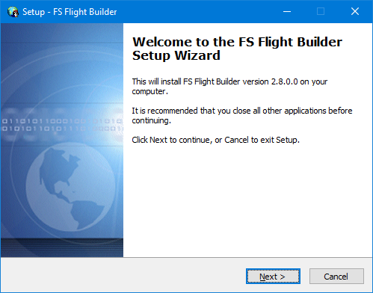

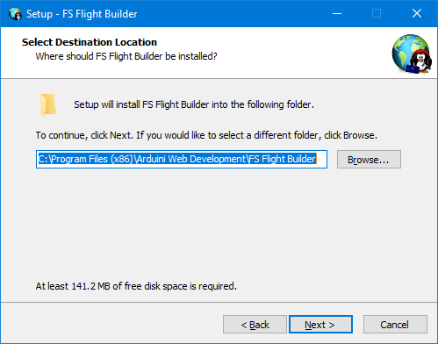

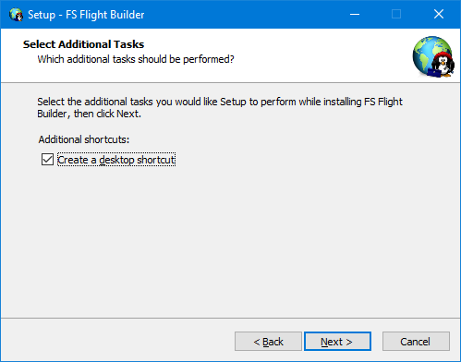

### Click the “Install” button to begin installation

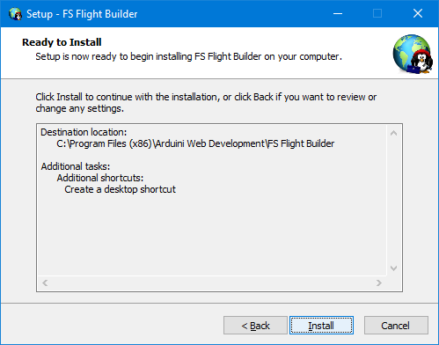

### Once the installation completes, the disclaimer screen is displayed

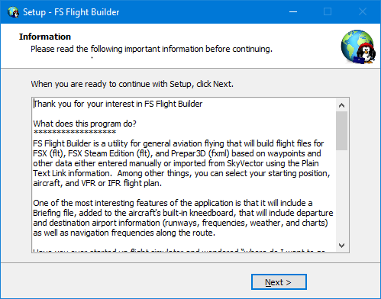

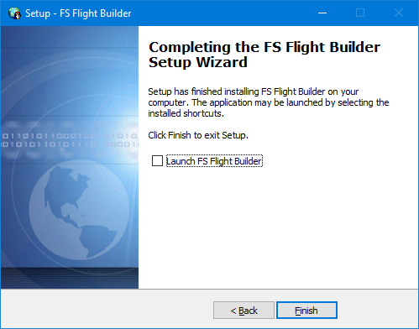

## Updating an Existing Installation (2.7 or earlier)

### In release 3.0, the file-based database was replaced with a SQL database. When you run the update, the application will recognize that you have a file-based system and will create the SQL database in the background, allowing you use the application while the database is being created.

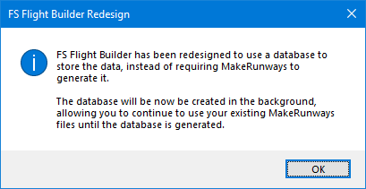

### The status of the installation can be seen at the bottom of the screen.

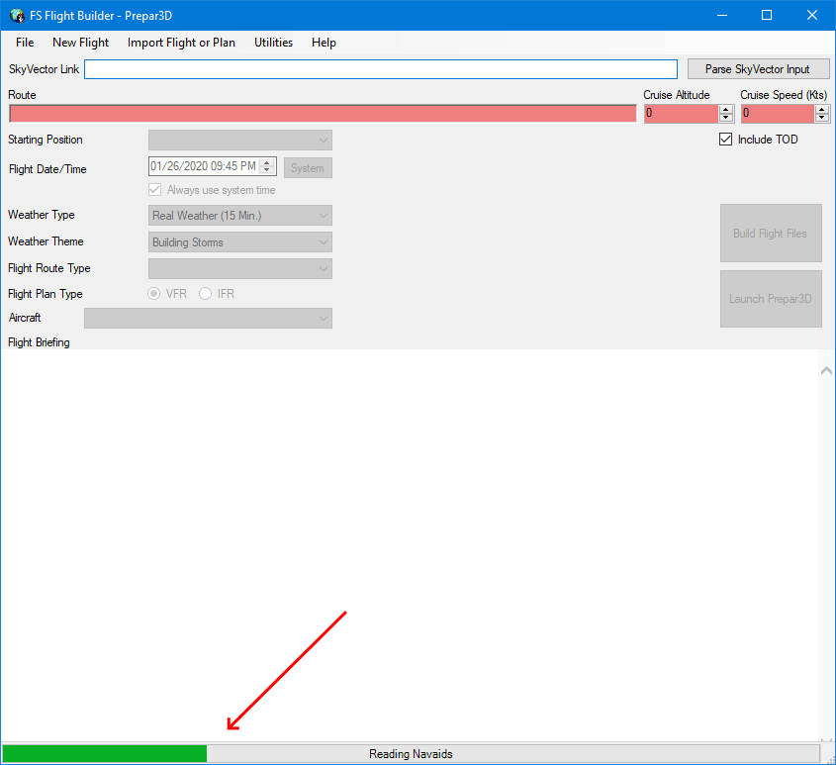

### Once the database has been created, it is recommended that you restart FS Flight Builder to ensure all configurations are updated

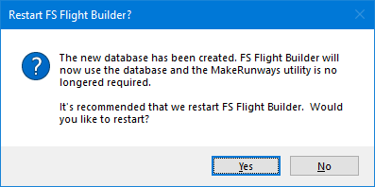

## Running the Application for the First Time

**It’s important to note that, because FS Flight Builder needs access to your flight sim folders and system registry (to determine which flight sims are installed), the FSFlightBuilder.exe must be configured for administrative access.**

### From Windows 10, administrative access can be added to the desktop icon using the following steps:

Right-click on the icon and select Properties:  
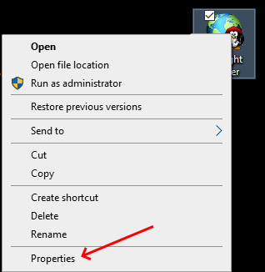

On the properties screen, select the Compatibility tab and check the “Run this program as an administrator” checkbox and click the OK button.  
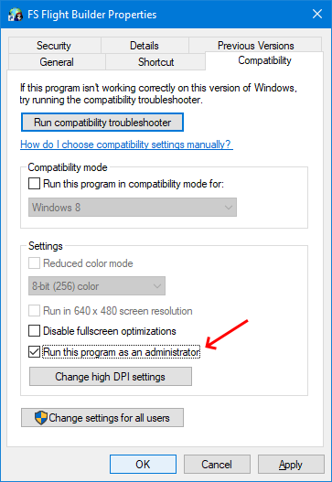

### If Administrator access is not installed, you will see this message:

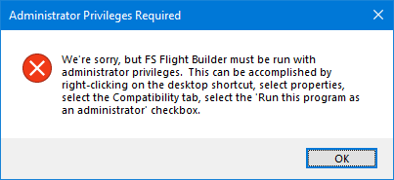

### When the program is run for the first time, it will need to create the database and read your flight sim files before it can start. You will see these messages:

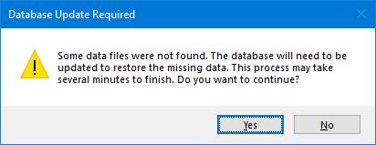  
  
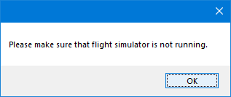

Click Yes, then OK to begin the update. This may take a few minutes.

### While the database files are being built, progress will be displayed as follows:

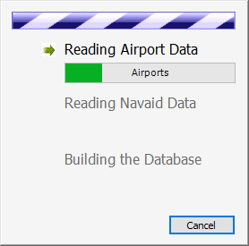

### Once the process is complete, you’ll be asked to provide your preference on checking for updates when the application starts.

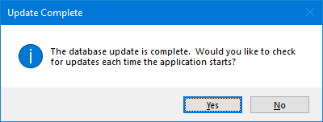

# USING FS FLIGHT BUILDER

## The FS Flight Builder Screen

This is the main FS Flight Builder screen. Each of the numbered items are described below.

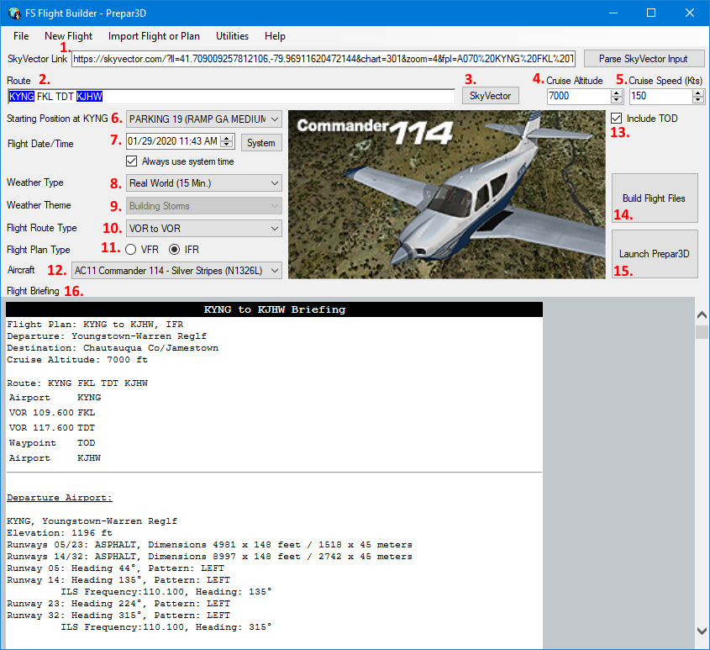

## SkyVector Link (1.)

### This is where you’ll past the flight plan link from SkyVector.com

Once your flight plan is in place, click on the Link button on the top right toolbar, then copy the information in the Plain Text Link box.

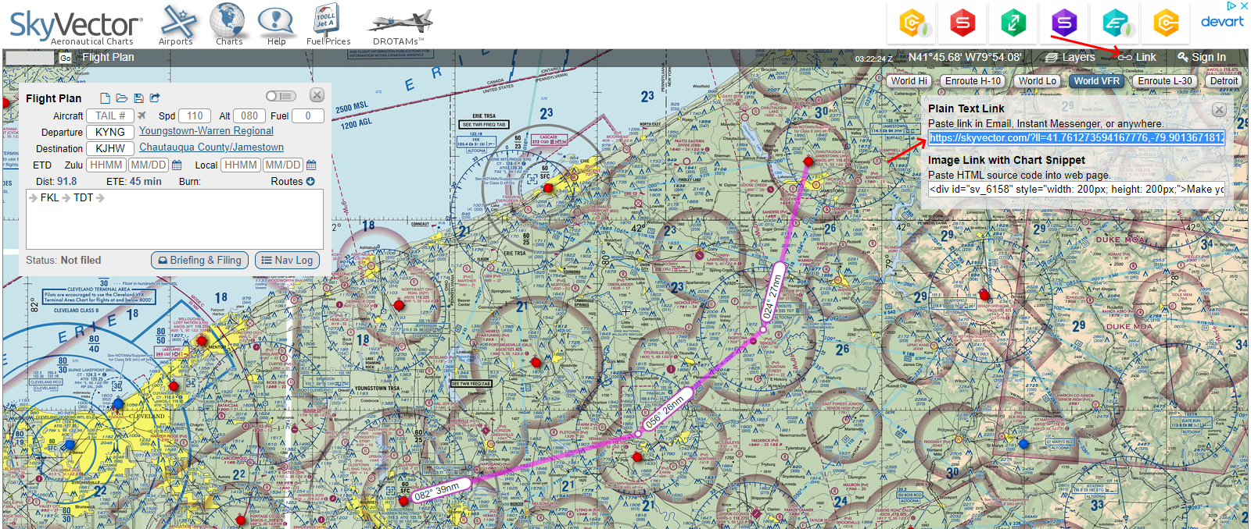

### Paste the link in the SkyVector Link textbox in FS Flight Builder

### Click on the Parse SkyVector Input button to create the flight route and add the altitude (if it was set in SkyVector)

## Route Box (2.)

### There are three ways to enter a route in FS Flight Builder.

The first way is to parse a SkyVector input as described above. The path can then be manually adjusted by typing in the “Route” box

The second way to enter a route is to simply enter it by hand.

The third way is to use the Destination Chooser utility, which is discussed later in this document.

Keep in mind that the route MUST start at an airport and end at an airport.

If victor airways are entered, FS Flight Builder will search the database to find the appropriate waypoints.

### If weather information is available for the airport, it will be highlighted in one of these colors:

**Green**: VFR conditions

**Blue**: MVFR conditions

**Magenta**: LIFR Conditions

**Red**: IFR Conditions

Hovering over an airport that is highlighted will show the current weather for that airport.

NOTE: A departure and destination airport must be entered in order to use any of the functionality described below.

## SkyVector Button (3.)

### Clicking this button will open SkyVector in your browser and pass in the route along with the selected altitude.

## Cruise Altitude Box (4.)

### The cruise altitude can come from the SkyVector input or can be entered manually

### It’s currently displayed in feet. A future enhancement will be made to allow you to choose imperial or metric units.

### If the route is entered in the Route box, hovering over the Altitude box will show the suggested altitude based on the direction of the route. For example, if flying VFR and the magnetic course is between 0 and 179 degrees, “Odd + 500” will be suggested.

**NOTE: The cruise altitude must be entered in order to use any of the functionality described below.**

## Cruise Speed Box (5.)

### The cruise Indicated Airspeed (in knots) can be entered manually, but will automatically adjust when an aircraft is selected.

## Starting Position List (6.)

### This list contains the possible aircraft starting positions based on the departure airport from the Route box.

### These should match up to the positions available in the flight simulator since they come from the airport database.

## Flight Date/Time Box (7.)

### Use this box to determine the date and time for your flight.

### If the “Always use system time” checkbox is selected, every new flight will set the flight date and time to the current date and time.

### The System button will set the Flight Date/Time box to the current system date and time.

## Weather Type List (8.)

### The Weather Type list is used to select the weather for your flight. Options are:

Theme  
Real World (Static)  
Real World (15 Min.)

## Weather Theme List (9.)

### Choose the weather for your flight.

The Weather Theme list is enabled if Theme is selected from the Weather Type list.

## Flight Route Type List (10.)

### This selection allows you to identify the flight route. Options are:

Direct

VOR to VOR

Low Victor Airways

High Victor Airways

## Flight Plan Type (11.)

### This selection will determine the type of flight plan that will be filed.

For VFR, it’s always a good idea to check the weather conditions at your departure and destination airports to make sure that VFR conditions actually exist.

If the departure or destination airports are in IFR conditions, a red “IFR Conditions” warning message will be displayed if VFR is selected.

## Aircraft List (12.)

### This list will contain all of the aircraft currently installed in your flight sim’s SimObjects\Airplanes folder.

### Once an aircraft is selected, the picture will be displayed, and the “Cruise Speed” will be updated.

## Include TOD Checkbox (13.)

### If this checkbox is checked, FS Flight Builder will calculate your Top Of Descent point and add it to your route.

NOTE: The TOD calculation does not account for wind conditions along your route.

## Build Flight Files Button (14.)

### Once all of the flight information is entered, this button will become enabled. Clicking it will open the Charts screen to allow you to choose any available charts for your departure and destination airports. Once the charts have been selected and the screen is closed, the briefing file will be created (described below).

NOTE: The chart service that produces the charts will be based on your selection in the Options screen. If set to Automatic, it will choose the FAA service if the flight is within the United States. Otherwise it will choose the AirCharts service.

## Launch Button (15.)

### Clicking on the Launch button will attempt to start the flight simulator and automatically load the Flight file created from the Build Flight Files button. It will try to launch the flight simulator without opening the simulator’s Startup screen.

### If the selected flight simulator is configured to show the startup screen, the application will do the following:

* Make a copy of the flight simulator config file
* Update the copy to turn off the startup screen option
* Rename the current config file to “AWD.cfg”.
* Rename the copied file to the flight simulator’s config file name

### When FS Flight Builder is closed, it will check to see if it updated the flight sim’s config file. If it did it will:

* Delete the updated config file
* Rename the “AWD.cfg” back to the original config file name, thereby restoring the configuration to its original settings.

## Flight Briefing (16.)

### When the “Build Flight Files” button is clicked, the following files are created:

* Flight files (.fxml for Prepar3D, .flt for either FSX version).
  + This includes the starting position, time of day, and aircraft
* The flight plan file
  + This includes the route, the flight route type, and the flight plan type
* The Mission file
  + This is the page that will be displayed in the aircraft’s kneeboard. It currently includes the basic flight information (departure / destination airports and cruise altitude). It also includes runway information (including lighting, traffic pattern, and ILS information), frequency information, weather (METAR) information (parsed text as well as the raw METAR), and charts.

PLEASE NOTE: An internet connection is required in order to get weather and chart information

# File Menu

Multiple function can be performed using the Menu. This section will explain each of the functions.

## Database: Update Aircraft Only

### Any time you add an aircraft to your flight simulator, you’ll want to select this option to update the application’s aircraft database to include the new aircraft.

NOTE: If you’re using Prepar3D and your aircraft are located outside of the primary Prepar3D path, the application should be able to find them. It will read the settings in the add-ons.cfg file, located in your AppData folder.

## Database: Update Full Database

### Whenever you add new scenery to your flight simulator, you’ll want to run this option to rebuild the airport and navaid databases.

## Options

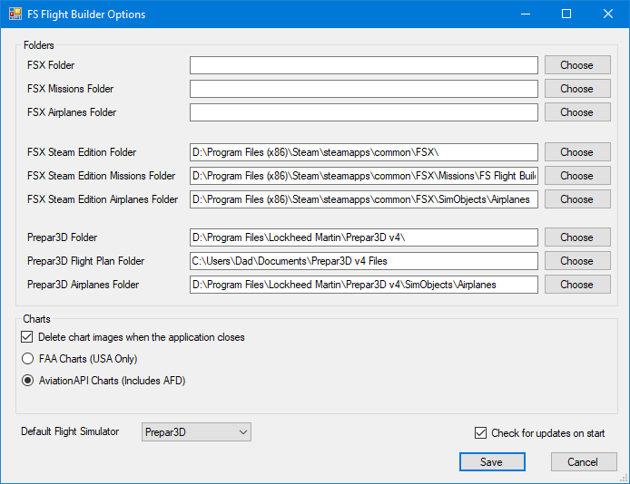

### The Options dialog is used to identify the folders for the flight simulator executable and flight plans. There are options to select folders for all three versions of flight simulator.

### The Charts section will allow you to choose the chart service you prefer.

The AirCharts service has been removed due to the discontinuation by the vendor. The AviationAPI service has been added, which provides the Airport Facility Directory long with the standard charts.

### The Default Flight Sim drop-down list is used to select the flight simulator you’d like to use if multiple installations are found.

NOTE: The flight Plan folder for FSX and FSX Steam Edition should point to a sub-folder of the Missions folder, while the Flight Plan folder for Prepar3D should point to the Flight folder (typically in My Documents).

When the program loads, it will try to find all of the installed flight simulators and automatically add the appropriate folders to the options screen.

## Aircraft Editor

### FS Flight Builder has the ability to calculate the top of decent for the flight. In order to do so, it will need some performance information regarding the descent rate and descent speed of the aircraft. This screen will allow you to enter that information.

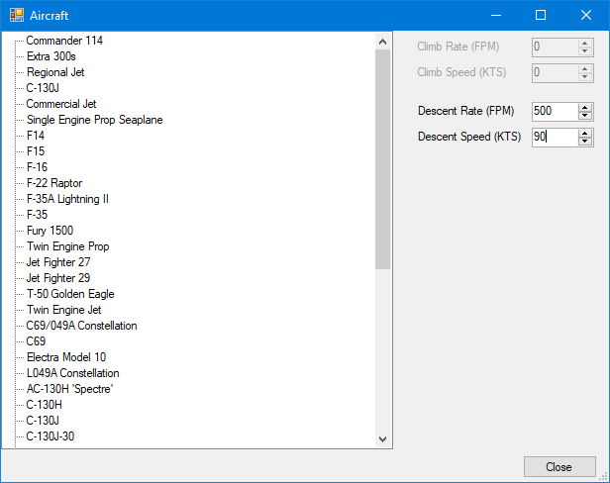

### Enter the descent rate and descent speed for each aircraft.

### Lastly, you can choose to automatically check for application updates each time FS Flight Builder is run. If an update is found, you’ll be given the option to install it and re-run the application.

## Check for Updates

### Select this option to manually check for application updates. If an update is found, you’ll be given the option to install it and re-run the application.

## Exit

### This option will close FS Flight Builder.

# New Flight

## Selecting this menu option will reset the FS Flight Builder screen to prepare for a new flight.

# Import Flight or Plan

## This option allows you to choose a previously saved flight (.fxml for Prepar3D and .flt for either FSX versions) or flight plan (.pln).

## Once a flight or flight plan is selected, the associated information will be updated on the FS Flight Builder screen.

# Utilities

## Destination Chooser

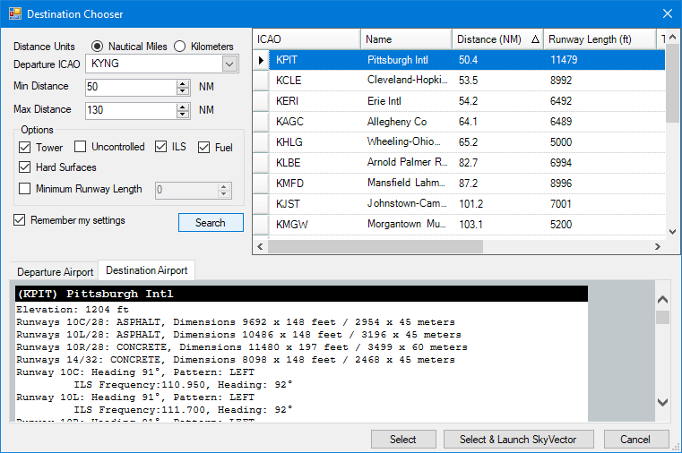

### Have you ever started up flight simulator and wondered “where do I want to go today”? This screen can help to solve that problem.

### The Destination Chooser screen allows you to enter your departure airport and choose various filters for your destination (i.e. distance, tower availability, ILS availability, runway length requirements, etc.).

### As you begin entering the airport ICAO in the Departure entry, the list will be filtered based on the information entered.

### Once the departure airport has been selected, information about the airport is displayed in Departure Airport tab found at the bottom left portion of the screen.

### Once you’ve selected your departure airport and any appropriate filters, clicking search will give you a listing of the airports that meet your criteria, sorted by distance (although you can sort any way you choose, even sort on multiple columns).

### Once you select your destination airport, the airport information will be displayed in the Destination Airport tab at the bottom of the screen.

### When ready, you can click the Select button to open the route in FS Flight Builder, or select Select & Launch SkyVector to create the route and open the route in SkyVector to select additional waypoints, etc.

# Help

## User Guide

### Opens this document.

## Change Log

### This option will show the changes that have occurred over the various releases of FS Flight Builder

## About

### Selecting this menu option will show the About screen, showing the legal information and current application version.

